NTAS 12 SBE 16 Preliminary Processing
201402011Nan Galbraith
Preliminary processing was done at sea by Seb Biggorre, these notes and some follow-up processing by N. G.

- Buoy Information

latitude = 14 deg 44.953 min North
longitude = 50 deg 56.976 min West
Anchor over: 2012,12,3,21,24,0
Anchor release: 2013,10,29,9,53,0
water_depth=5035 m
deck_height = 80 cm
watch_circle = 4.0 nm
wmo_platform_code = '48401';

- SBE16s deployed

  - From Deployment xls
 | Depth | Rate | Start Rec |  | Spike | Spike Start | Spike Stop
Serial | Meters | minutes | Date | Start Time | Date | Time | Time
1877 | 4998* | 30 | 11/14/12 | 01:00 | 30-Nov-12 | 14:55:00 | 16:34:57
1878 | 4998* | 30 | 11/14/12 | 01:00 | 30-Nov-12 | 14:55:00 | 16:34:57

* originally recorded as 4940, (Corrected depth 5035)-37m off bottom = 4998

  - From recovery xls

SN | True Time | UTC Date | Internal Time | Internal Date | Stop Sampling | Records | Spike Date | Spike Start | Spike End
1877 | 11:05:00 | 26-Oct-2013 | 10:57:19 | 26-Oct-2013 | 11:04 | 16629 | 25-Oct-2013 | 12:52:00 | 14:02:00
1878 | 11:26:00 | 26-Oct-2013 | 11:22:05 | 26-Oct-2013 | 11:25 | 1243 | 25-Oct-2013 | 12:52:00 | 14:02:00

Note that 1877 had poison plugs, 1878 did not; a comparison won’t be very useful since 1878 failed before it could foul.

- Preliminary processing

Because 1878 failed, details are given for 1877.

Data uploaded from instruments into hex files; processed on a PC on Jan 06 2014 with SBE16_1877.xmlcon (which provides more info than the ‘con’ files) and UOPDatCnv.psa on Jan 06 2014; pressure value (used in salinity calculation) set to 5087.0365 (which, I think, is correct for 4998m).
Data converted to Matlab with (local copy of) getsbe16.m, version 2012/12/12.

- Timing marks

  - Pre-deployment spikes

SN | Spike Date | Start Time | Stop Time
1877 | 30-Nov-12 | 14:55:00 | 16:34:57
1878 | 30-Nov-12 | 14:55:00 | 16:34:57

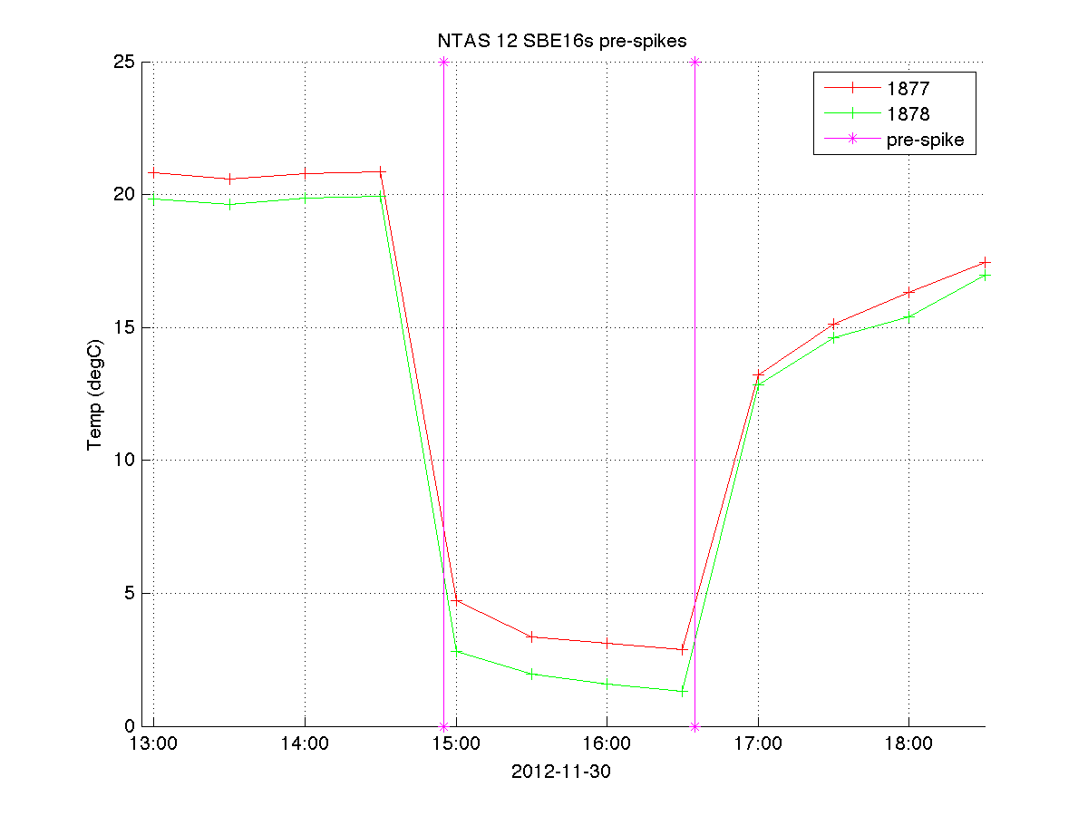

  - Post-recovery spikes

SN | Spike Date | Spike Start | Spike End
1877 | 25-Oct-2013 | 12:52:00 | 14:02:00
1878 | 25-Oct-2013 | 12:52:00 | 14:02:00

Post-spike on 1877 only, appears fine; time word is generated in software for SBE 16s.

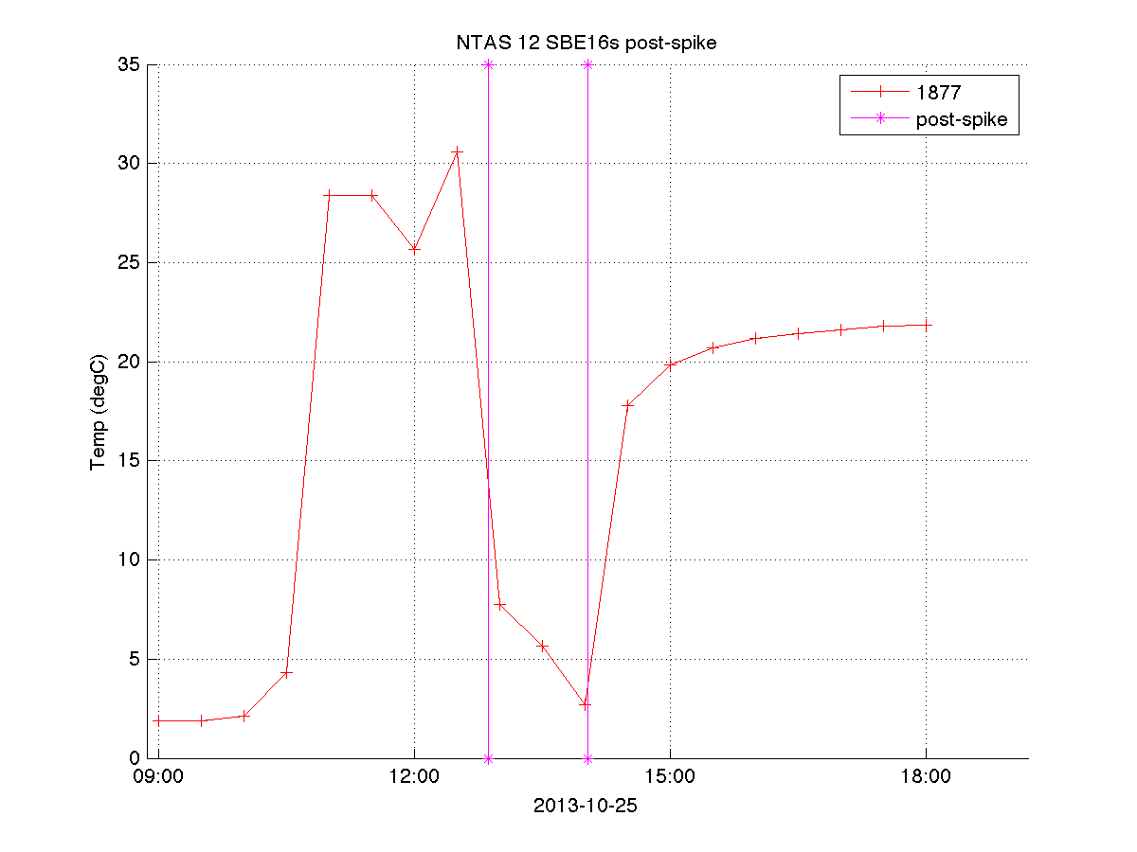

- Data Return
  - Inventory

SN | first | last | #points | #expt | rate  mins | return  %
1877 | 03-Dec-2012 23:30 | 25-Oct-2013 09:30 | 15621 | 15621 | 30 | 100
1878 | 03-Dec-2012 23:30 | 09-Dec-2012 22:00 | 286 | 15621 | 30 | 1.83

  - Inventory plot

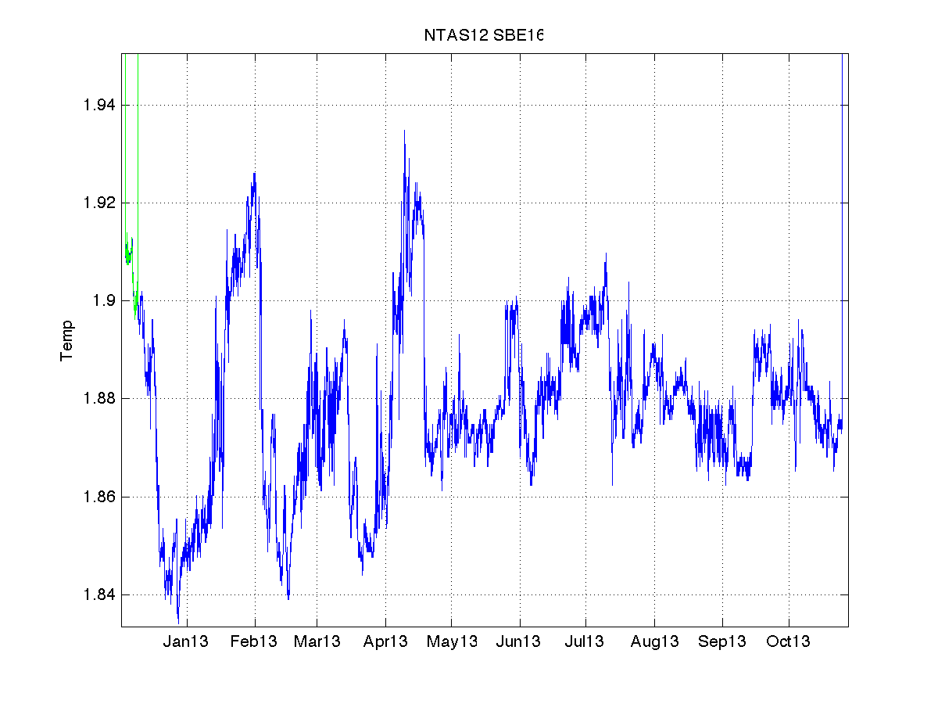

- Calibrations
Calibration information for 1877, since 1878 was so short.
  - Pre-cal:
<sensor Channel="1" >
# <TemperatureSensor SensorID="55" >
# <CalibrationDate>28-Feb-09</CalibrationDate>
# <UseG_J>1</UseG_J> (<A>,<B>, <C> <D>,<F0_Old> all 0.0)
# <G>4.16205521e-003</G>
# <H>6.01661873e-004</H>
# <I>5.30278306e-006</I>
# <J>-1.69563254e-006</J>
# <F0>1000.000</F0>
# <Slope>1.00000000</Slope> <Offset>0.0000</Offset>
# <ConductivitySensor SensorID="3" >
# <CalibrationDate>28-Feb-09 </CalibrationDate>
# <UseG_J>1</UseG_J>
# <!-- Cell const and series R are applicable only for wide range sensors. -->
# <SeriesR>0.0000</SeriesR>
# <CellConst>2000.0000</CellConst>
# <ConductivityType>0</ConductivityType>
# <Coefficients equation="0" >
# <A> <B> <C><D><M> all 0.0
# <CPcor>-9.57000000e-008</CPcor>
# </Coefficients>
# <Coefficients equation="1" >
# <G>-3.99335464e+000</G>
# <H>4.76253826e-001</H>
# <I>1.28168513e-003</I>
# <J>-3.56599563e-005</J>
# <CPcor>-9.57000000e-008</CPcor>
# <CTcor>3.2500e-006</CTcor>

  - Post-cals:
20140619 reran with post-cals; updated software to read xmlcon to get applied pressure that was used in the sbe_sal calculation.

SN 1877
<sensor Channel="1" >
# <TemperatureSensor SensorID="55" >
# <SerialNumber>1877</SerialNumber>
# <CalibrationDate>04-Feb-14</CalibrationDate>
# <UseG_J>1</UseG_J> (<A>,<B>, <C> <D>,<F0_Old> all 0.0)
# <G>4.16194039e-003</G>
# <H>6.01358716e-004</H>
# <I>5.05758797e-006</I>
# <J>-1.75288003e-006</J>
# <F0>1000.000</F0>
# <Slope>1.00000000</Slope> <Offset>0.0000</Offset>
# </TemperatureSensor>
# </sensor>
# <sensor Channel="2" >
# <!-- Frequency 1, Conductivity -->
# <ConductivitySensor SensorID="3" >
# <SerialNumber>1877</SerialNumber>
# <CalibrationDate>04-Feb-14</CalibrationDate>
# <UseG_J>1</UseG_J>
# <!-- Cell const and series R are applicable only for wide range sensors. -->
# <SeriesR>0.0000</SeriesR>
# <CellConst>2000.0000</CellConst>
# <CPcor>-9.57000000e-008</CPcor>
# </Coefficients>
# <Coefficients equation="1" >
# <G>-4.00143663e+000</G>
# <H>4.78102614e-001</H>
# <I>9.18882225e-004</I>
# <J>-1.66957943e-005</J>
# <CPcor>-9.57000000e-008</CPcor>
# <CTcor>3.2500e-006</CTcor>

From postcal/SBE16_1877.xmlcon (also in pre-cal xmlcon files) :
MooredPressure 5087.03650

Overplots of pre and post calibrations for Salinity showed that the 2 units agree more closely using pre-cals; the plot was done on the time period where both were operating:
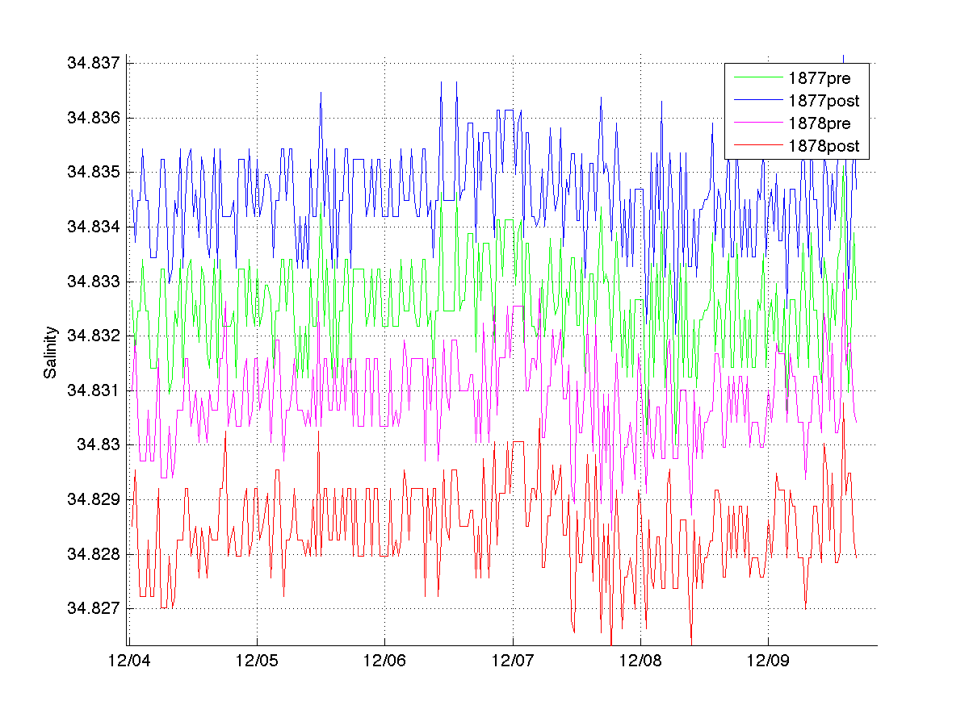

Temperature plot of the same time period shows that either temperature cal is good:
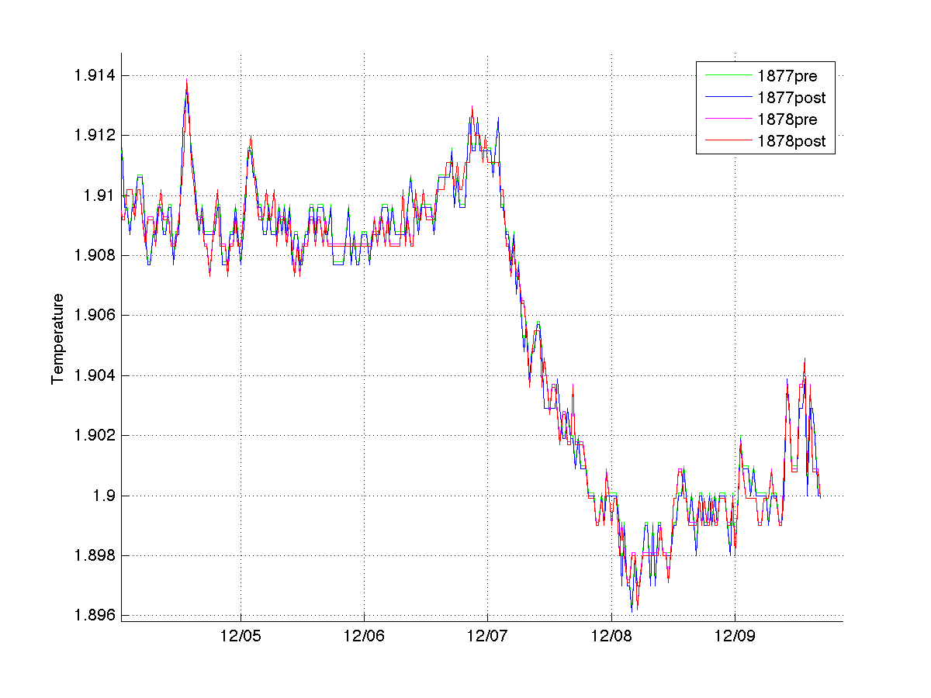
Adding NTAS 11 deep SBE 16s, which stayed on station when that buoy went adrift, confirms that the pre-cals are better.
Precal:
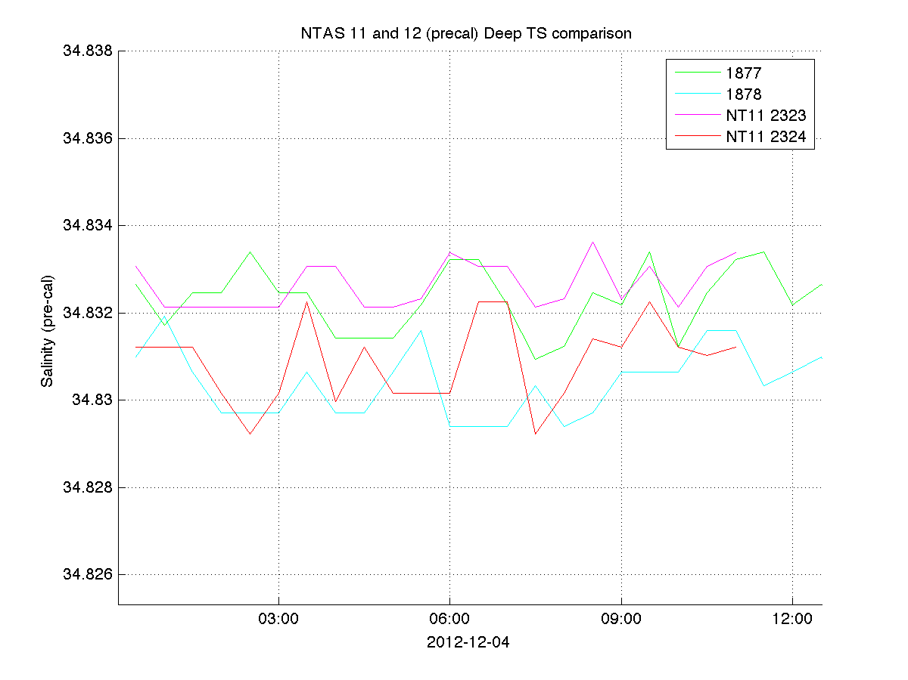

Postcal:
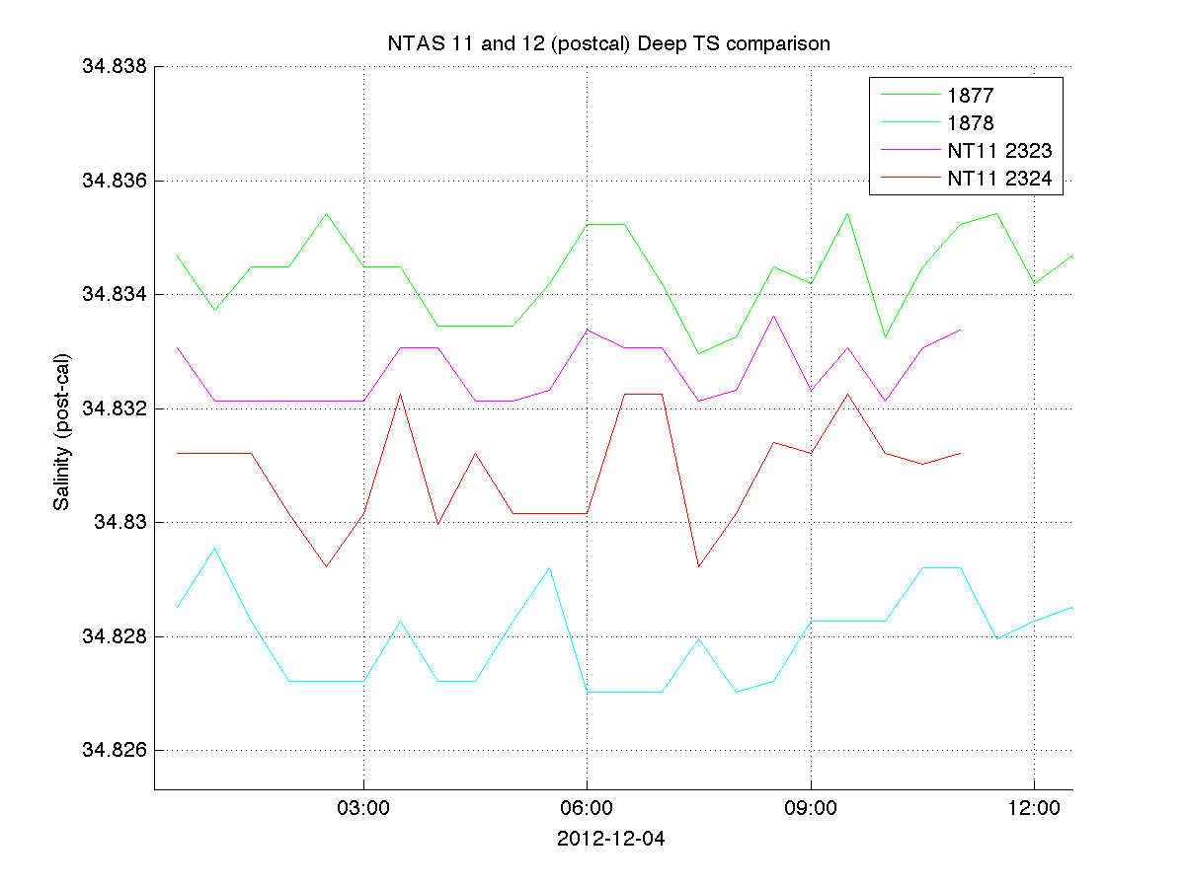

- Create combined data file
On Cougar, using matlab script make_deepts_ntas12, the pre-cal matfiles were combined into ntas12_deepTS.mat. The time limits were
03-Dec-2012 22:30:00 to 25-Oct-2013 09:30:00, with 15623 records. The truncation included a max limit on temp, for 1877, 1.937, and for 1878, 1.915; this was because there were high values as the instruments were launched and also when 1878 failed. This file was copied to buoy2 in ntas_for_distribution in case there are questions about the data when it’s published on oceansites.

- OceanSITES output
Matlab script do_deepTS_to_OTS_ntas12 read in ntas12_deepTS.mat and created
ntas/OS_NTAS_2012_D_deepTS.nc, which was copied to our web server and sent to NDBC’s OceanSITES server via ftp.

