In-situ observations of atmospheric and oceanic conditions near and below the ocean surface have been gathered for over 10 years from a research buoy located at 85 °W 20 °S in the subtropical Pacific. On this mooring, named Ocean Sites Stratus (hereafter Stratus), data are sampled every minute.

In the figures below, data were averaged to hourly values (blue), a 30 days moving average was applied on data (red) and the annual cycle (green) was computed by averaging monthly averages over 10 years.

Figure 1 shows SST. The lower panel is the difference with respect to the annual cycle of the hourly data (blue) and lowpassed –or moving-averaged- data (red). A clear anomaly stands out in 2007 when SST was much colder than usual. In 2007, La Nina conditions developed over the tropical Pacific as seen by the Nino1.2 index (black). To the naked eye, there is a seemingly a correlation between Nino1.2 index and SST anomalies at the Stratus mooring between 2006 and 2008, but anti-correlation at other times. It is not clear to what extent large scale climate systems shape these observations and what role the local processes play. We intend to use these detailed observations to sort this question out and provide tools for the climate research community.

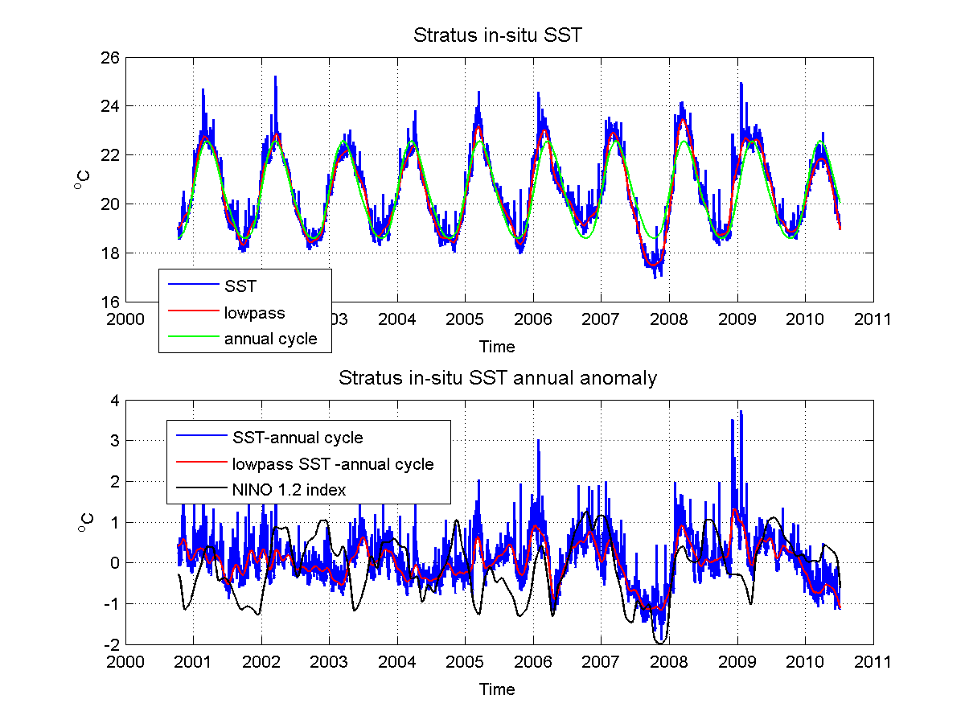
Figure 1. SST from Stratus mooring. Upper: hourly data (blue), moving average (red) and annual cycle (green). Lower: difference between SST (hourly in blue, moving average in red) and annual cycle. Nino 1.2 index is in black.

Observations show that the interannual variations seen in SST are also present in atmospheric proxies, like air temperature (Figure 2), barometric pressure (Figure 4) or wind speed (Figure 5). In 2007, air temperature was colder, pressure higher and winds stronger. The atmosphere and the ocean are not in thermal equilibrium, as their response times to seasonal forcing differ. In figure 3, the difference between SST and air temperature is very seasonal indeed, but again, the inequilibrium was enhanced in 2007.
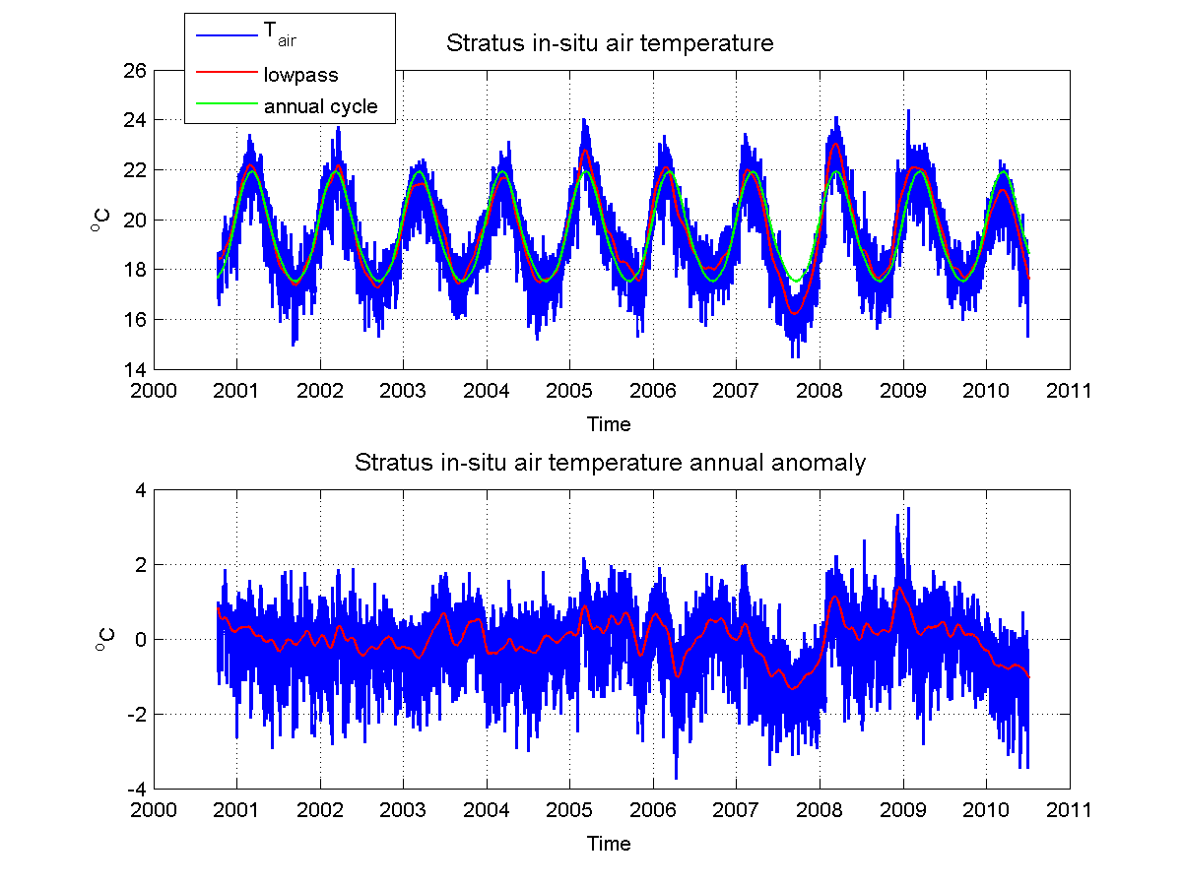

Figure 2. As in Fig. 1 but for air temperature.

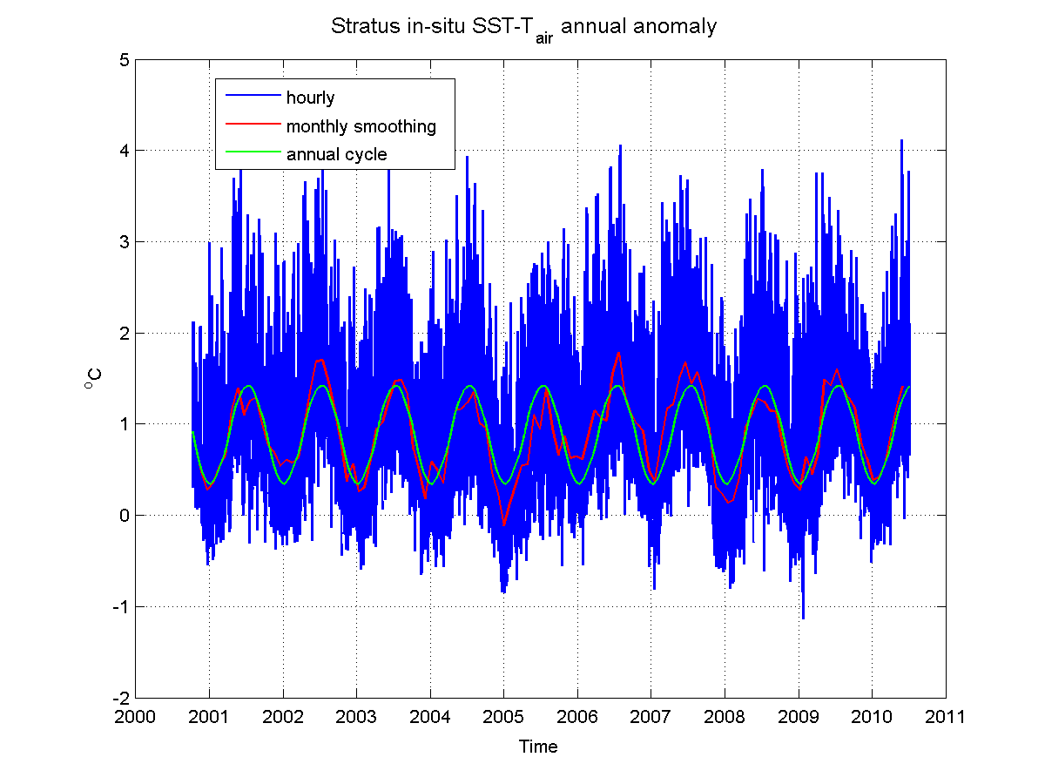
Figure 3. As in Fig. 1 but for SST minus air temperature.

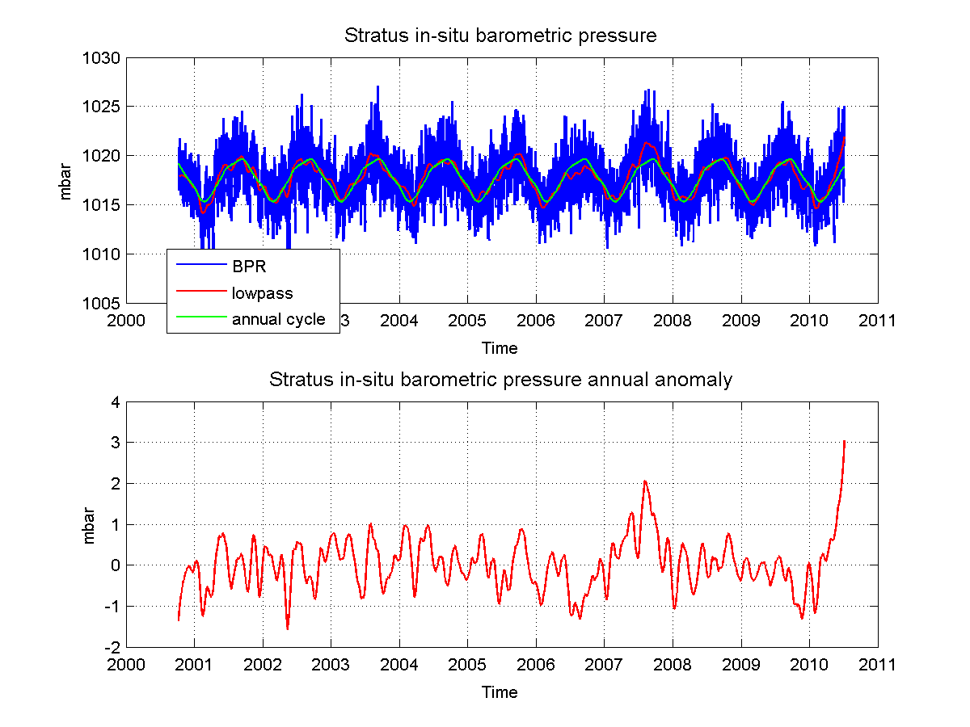

Figure 4. As in Fig. 1 but for barometric pressure.

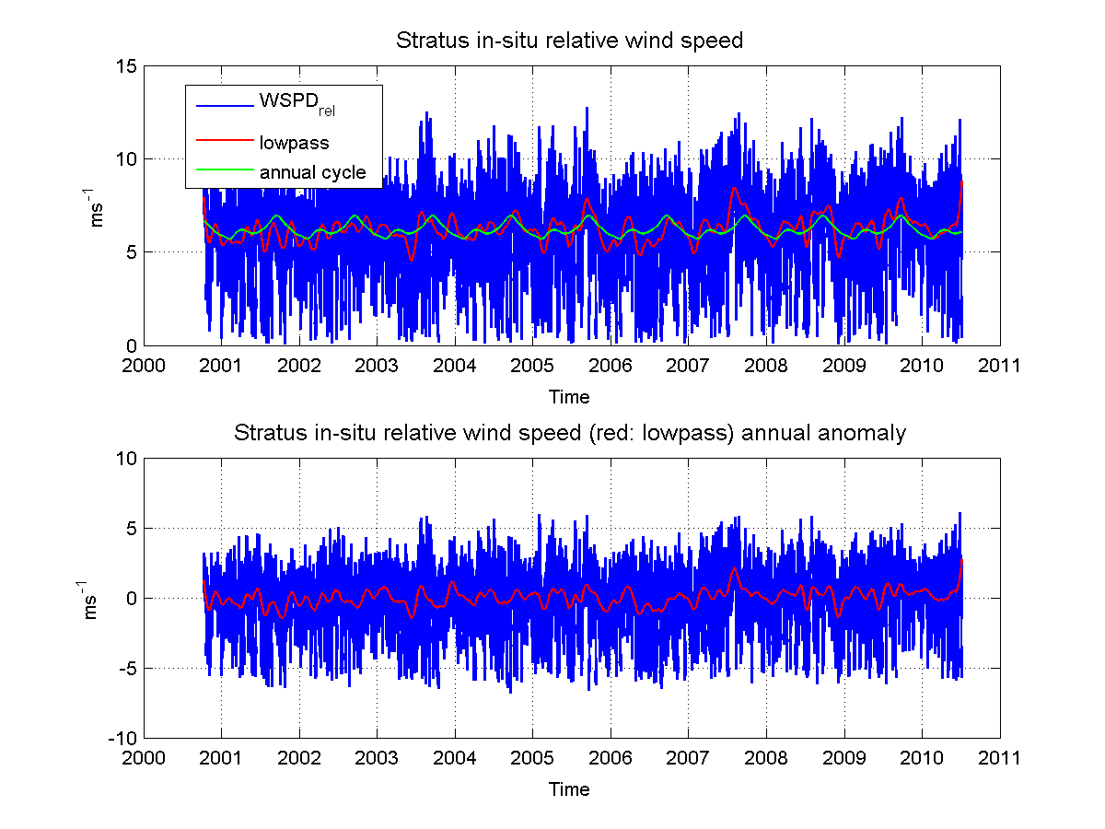
Figure 5. As in Fig. 1 but for wind speed relative to water surface.

Radiation forcing also varies on interannual time scales, although no obvious link can relate to changes in SST for example (Figures 6, 7)..
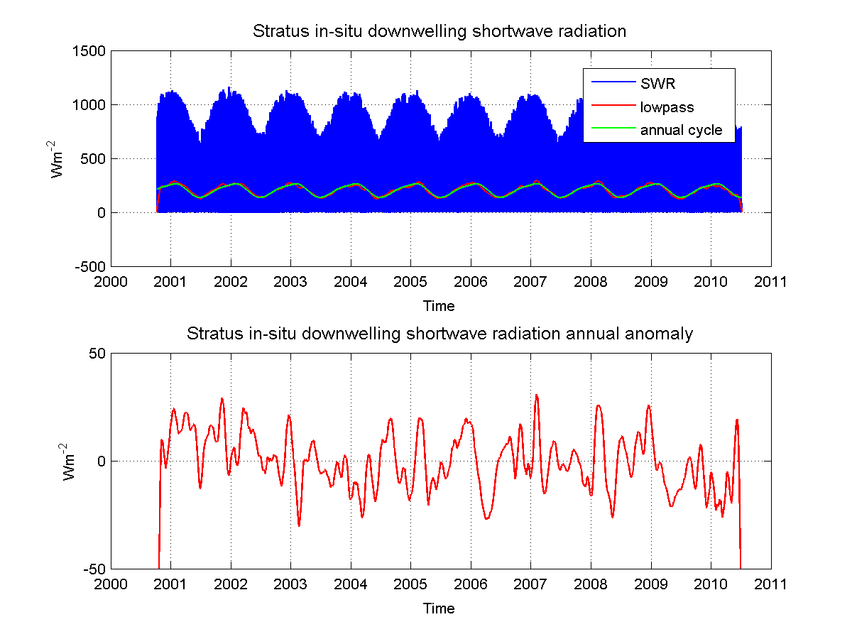

Figure 6. As in Fig. 1 but for shortwave downwelling radiation.

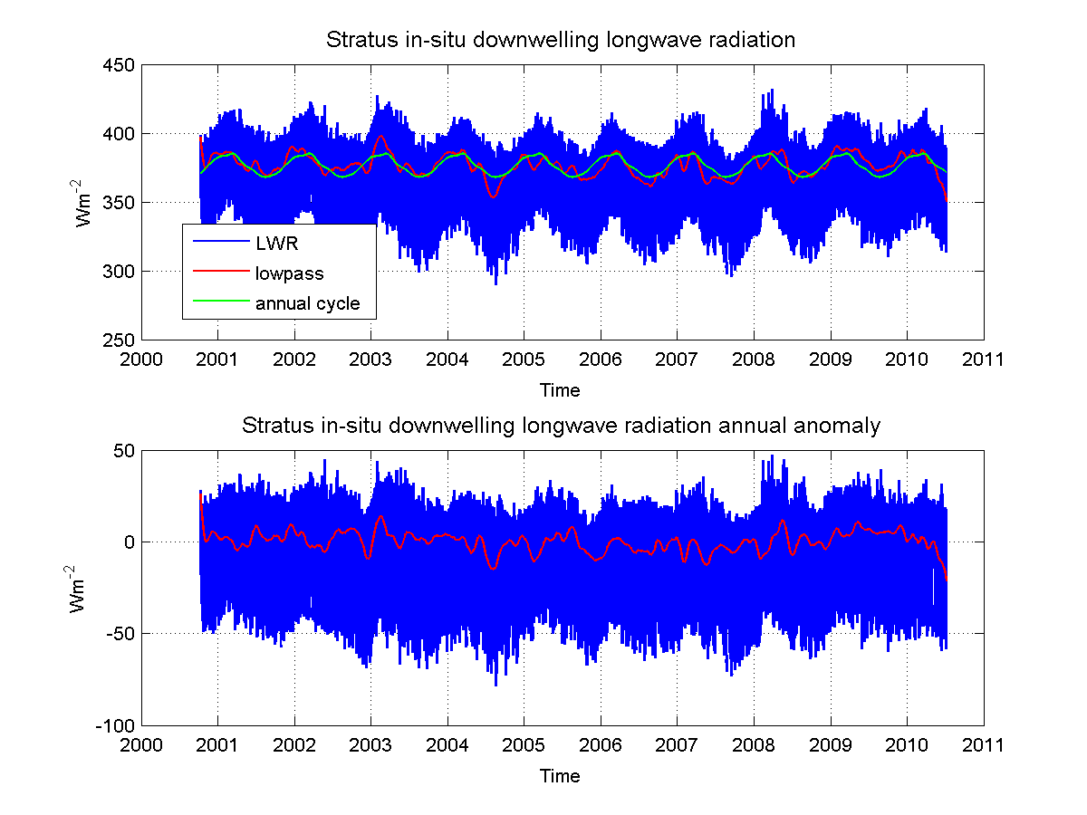

Figure 7. As in Fig. 1 but for longwave radiation radiation.

As was seen in SST, sea surface salinity (SSS) changes on interannual time scales (Figure 8). In 2007, surface waters were relatively fresher for example. Also remarkable are the abrupt changes in SSS in 2006 and 2007. More work will be done to relate these to subsurface processes, in particular the ones that control the oceanic mixed layer.
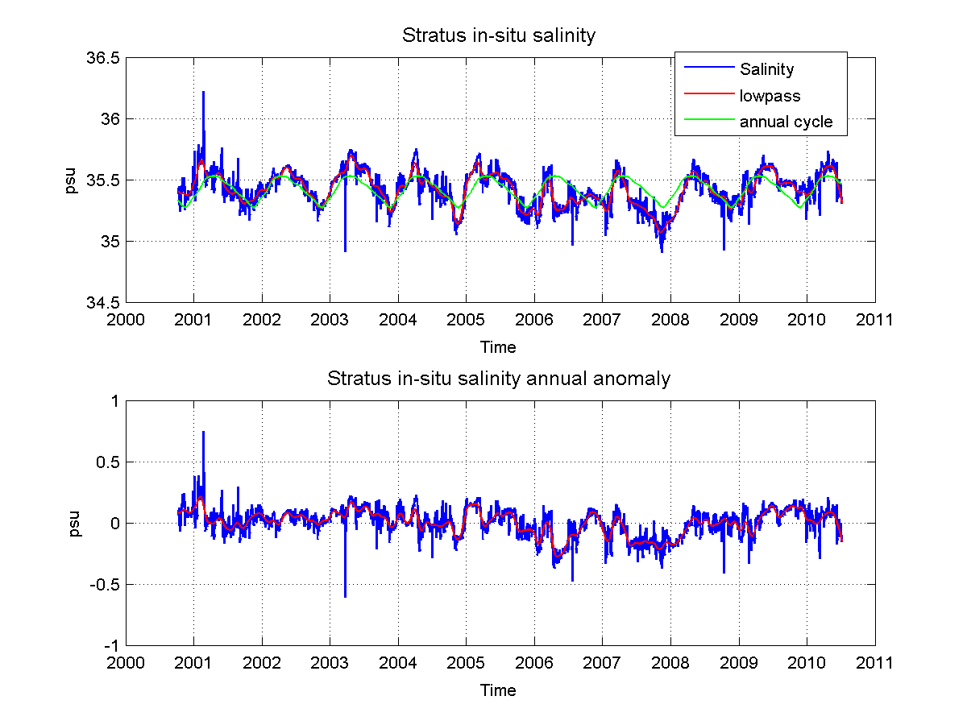
Figure 8. As in Fig. 1 but for surface salinity.

